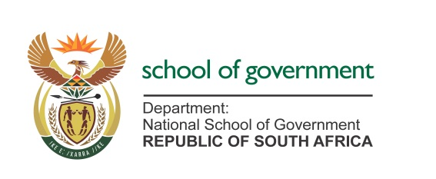

Media Advisory
Date: 15 April 2026

The National School of Government and COMENSA will Sign a Landmark MOU to Professionalise Coaching and Mentoring in the Public Sector
The Acting Principal of the National School of Government (the NSG), Ms Phindile Mkwanazi and the Chief Executive Officer of Coaches and Mentors of South Africa (COMENSA), Ms Veronica Kietzmann-Cronje, will sign a Memorandum of Understanding (MoU). This historic event will take place during the 20-year anniversary of COMENSA Africa Conference 16-17 April 2026.
The partnership marks a defining moment in the professionalisation of Coaches, Mentors and Supervisors in the public service. By collaborating with COMENSA—a professional body recognised by the South African Qualifications Authority (SAQA)—the NSG aims to integrate world-class coaching, mentoring, and supervision standards into the South African public sector. The agreement focuses on advancing the competency of coaches, promoting ethical behaviour, and co-hosting capacity-building activities such as workshops and seminars.
Key Highlights of the Conference
• Thought leadership discussions on the future of coaching in Africa
• Exploration of digitalisation and artificial intelligence in coaching
• Showcasing African research and academic contributions to the global Body of Knowledge
• Industry dialogue on regulation, ethics, and professional standards
The Conference theme, "From Seed to Significance: Nurturing Growth, Cultivating Legacy", embodies this alignment and partnership.
Media is invited as follows:
- DATE: Friday, 17 April 2026.
- TIME: 07:00 -08:00
- VENUE: Birchwood Hotel & OR Tambo Conference Centre, Gauteng.
- RSVP: Dikeledi Mokgokolo 082 888 2355/ Malebo Ralehlaka 082 802 1752

