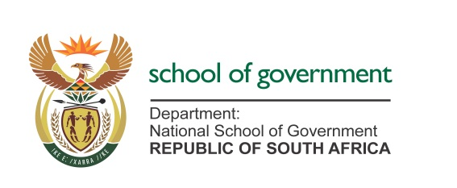

MEDIA ADVISORY
TO: ALL MEDIA
FOR IMMEDIATE RELEASE
DATE: 10 APRIL 2026

MINISTER BUTHELEZI TO LAUNCH TRANSFORMATIVE DIGITAL GOVERNANCE TRAINING IN PARTNERSHIP WITH RUSSIAN PRESIDENTIAL ACADEMY.

The Minister for the Public Service and Administration, Inkosi Mzamo Buthelezi, will on Monday, 13 April 2026, officially welcome a high-level delegation from the Russian Presidential Academy of National Economy and Public Administration (RANEPA) to launch a week-long executive training programme focused on the digital transformation of the public sector.

Hosted by the National School of Government (NSG), this programme marks the first major implementation of the five-year Cooperation Agreement signed between the NSG and RANEPA in November 2025. The initiative is a direct response to the Government of National Unity’s mandate to build a capable, ethical, and developmental state by equipping public servants with 21st-century digital competencies.
Distinguished practitioners from RANEPA’s Graduate School of Public Management will lead sessions for South African public servants on critical modern governance themes, including:
▪ Regulatory frameworks for digital development.
▪ GovTech platforms and smart city systems.
▪ Artificial Intelligence (AI) and data management in the public sector.
▪ Digital feedback mechanisms to improve citizen-centric service delivery.
"The public service must digitally transform, or it will become irrelevant to the very people it exists to serve," says Minister Buthelezi. "This partnership brings world-class expertise to our most critical challenge: ensuring every citizen can access government services efficiently and without delay".
Members of the media are invited to attend the opening session as follows:
DATE: Monday, 13 April 2026
TIME: 09:00 AM
VENUE: Centurion River Meadow Manor.
Enquiries & RSVPs: Dikeledi Mokgokolo 0828882355 or Malebo Ralehlaka 082 802 1752

