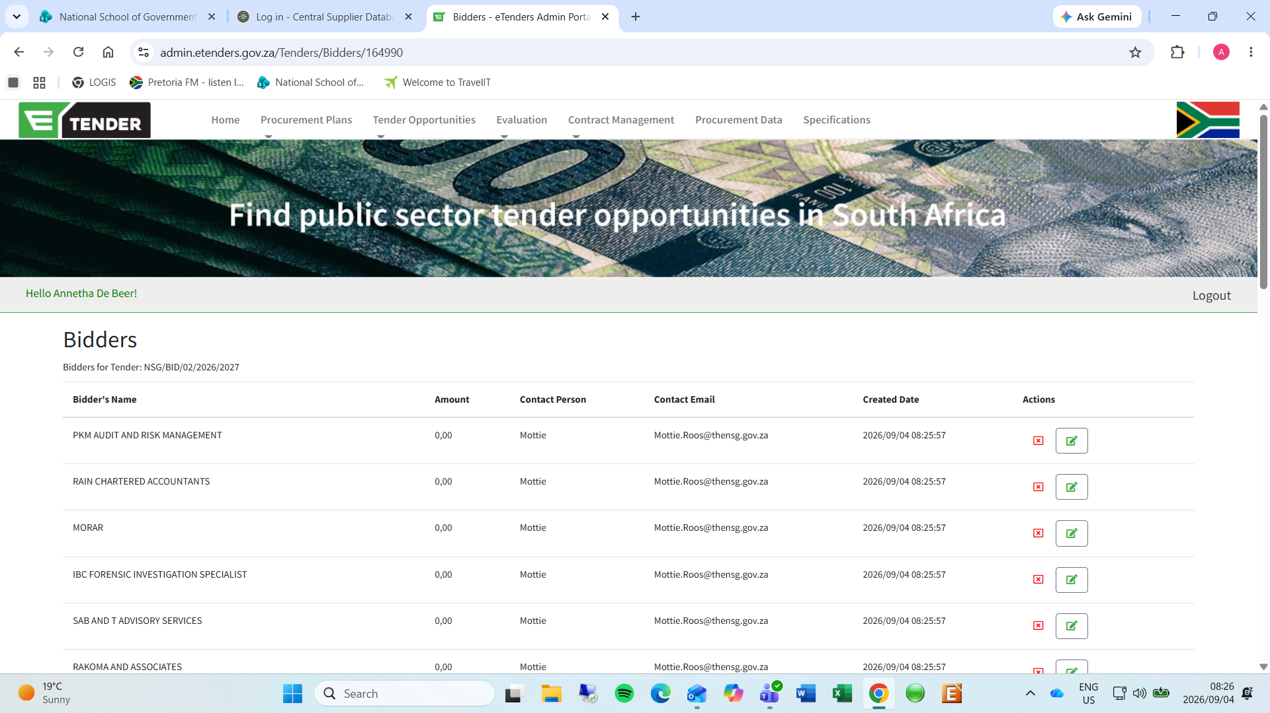

Bidders
Bidders for Tender: NSG/BID/02/2026/2027
Bidder's Name | Amount | Contact Person | Contact Email | Created Date | Actions
PKM AUDIT AND RISK MANAGEMENT | 0,00 | Mottie | Mottie.Roos@thensg.gov.za | 2026/09/04 08:25:57
RAIN CHARTERED ACCOUNTANTS | 0,00 | Mottie | Mottie.Roos@thensg.gov.za | 2026/09/04 08:25:57
MORAR | 0,00 | Mottie | Mottie.Roos@thensg.gov.za | 2026/09/04 08:25:57
IBC FORENSIC INVESTIGATION SPECIALIST | 0,00 | Mottie | Mottie.Roos@thensg.gov.za | 2026/09/04 08:25:57
SAB AND T ADVISORY SERVICES | 0,00 | Mottie | Mottie.Roos@thensg.gov.za | 2026/09/04 08:25:57
RAKOMA AND ASSOCIATES | 0,00 | Mottie | Mottie.Roos@thensg.gov.za | 2026/09/04 08:25:57
INDYEBO | 0,00 | Mottie | Mottie.Roos@thensg.gov.za | 2026/09/04 08:25:57
G M SOLUTIONS | 0,00 | Mottie | Mottie.Roos@thensg.gov.za | 2026/09/04 08:25:57
LUNIKA CHARTERED ACCOUNTANTS AND AUDITORS | 0,00 | Mottie | Mottie.Roos@thensg.gov.za | 2026/09/04 08:25:57
NGUBANE MANAGEMENT CONSULTANTS | 0,00 | Mottie | Mottie.Roos@thensg.gov.za | 2026/09/04 08:25:57
PHOLELA BUSINESS ADVISORY | 0,00 | Mottie | Mottie.Roos@thensg.gov.za | 2026/09/04 08:25:57
XABACHA SA | 0,00 | Mottie | Mottie.Roos@thensg.gov.za | 2026/09/04 08:25:57
OMA CHARTERED ACCOUNTANTS | 0,00 | Mottie | Mottie.Roos@thensg.gov.za | 2026/09/04 08:25:57
MMM ADVISORY SERVICES | 0,00 | Mottie | Mottie.Roos@thensg.gov.za | 2026/09/04 08:25:57
THE ETON GROUP | 0,00 | Mottie | Mottie.Roos@thensg.gov.za | 2026/09/04 08:25:57
SAMBA SOLUTIONS | 0,00 | Mottie | Mottie.Roos@thensg.gov.za | 2026/09/04 08:25:57
MGI RAS | 0,00 | Mottie | Mottie.Roos@thensg.gov.za | 2026/09/04 08:25:57
THAMANI ADVISORY | 0,00 | Mottie | Mottie.Roos@thensg.gov.za | 2026/09/04 08:25:57
SEKELAXABISO CA | 0,00 | Mottie | Mottie.Roos@thensg.gov.za | 2026/09/04 08:25:57
TIC AND MEND | 0,00 | Mottie | Mottie.Roos@thensg.gov.za | 2026/09/04 08:25:57
KETTLE CONSULTING | 0,00 | Mottie | Mottie.Roos@thensg.gov.za | 2026/09/04 08:25:57
KEP CONSULTING | 0,00 | Mottie | Mottie.Roos@thensg.gov.za | 2026/09/04 08:25:57
CHAVANI RISK ADVISORY AND FORENSIC SERVICES | 0,00 | Mottie | Mottie.Roos@thensg.gov.za | 2026/09/04 08:25:57

